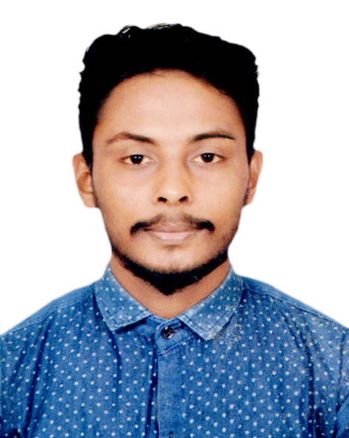
Curriculum Vitae
of
Md. Shahin

Mailing Address:

West Shewrapara,
Mirpur-10, Dhaka-1216
Cell- 01913298812

Career Objective

I want to begin my career within an organization where my education, experience and communication skills will be maximized and I can anticipate making progress in goal oriented performance for the benefit of my employer.

Educational Qualification
p

Bachelor Of Social Science [B.S.S]
Name of Institution : Govt. Bangabandhu College
Board : National University
Subject : B.S.S
Result : On Going
Seassion : 2019-20

Higher Secondary Certificate [ H.S.C ]

Name of Institution : Tazumuddin Govt. College
Board : Barisal
Group : Humanities
Result : GPA : 3.17 (Out of 5.00)
Passing Year : 2019

Secondary School Certificate [ S.S.C ]

Name of Institution : Dholigar Nagar High School
Board : Barisal
Group : Science
Result : GPA: 4.18 (Out of 5.00)
Passing Year : 2017

Computer Proficiency

- Microsoft Office XP (MS Word, MS Excel, MS Power Point.
- Internet Browsing (Web Browsing, Send / Receiving E-mail)

Interest & Hobbies
- Public Relations, Traveling, Cricket & Football playing etc.
Language Proficiency

- English: Proficiency in writing, reading, speaking & listening.
- Bengali: Proficiency in writing, reading, speaking & listening.

Personal Information

Father's Name : Sultan Ahammed
Mother's Name : Samsun Nahar
Date of Birth : 31/12/2000
Marital Status : Un-married
Religion : Islam
Nationality : Bangladeshi
Gender : Male
Height : 5'-6"
Weight : 55KG
Blood Group : O+

Permanent Address:

Vill- Uttar Chanchra, Post- Chanchra
Upzila- Tazumuddin, Dist- Bhola

Working Experience:
Name Of Organization : Pharmacy (Homeopathic)
Designation : Sales Man
Duration : 1 Year 3 Month (From 1st July 2019 to 30th October 2020)

Signature: --------------------------------
Shahin
Date:

